Customer Questionnaire – Water Piping Materials
The Sabine Parish Water Works District #1 is required to update our lead and copper sample plan and complete an inventory of the service line materials in our distribution system by October 16, 2024. To assist with this endeavor, we are asking our customers to complete the brief survey below.

We understand that you may not be aware of your plumbing or service line materials and that is okay. However, we ask that you complete the questionnaire to the best of your ability and return it to us using the instructions provided at the end of the survey. We thank you for your cooperation in helping us comply with the Federal requirement. If you have any questions you can reach us at: 318-256-6489.

Customer Information:
Name of Person filling out this questionnaire: _______________________________________________________

Phone Number should we have questions: _________________________________________________________

Do you own the property or are you renting? ___Owner ___Renter

Property Information:

Address (use separate sheet for each property): _____________________________________________________

Structure Type: ___Residential Home ___Multi-Family Residential ___Commercial ___Industrial

Year Built: ___Constructed before 1989 ___Constructed on or after 1989 ___Unknown

Service Line Schematic:
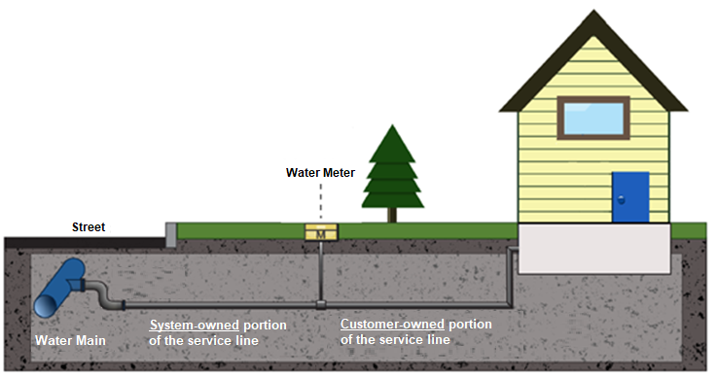

As shown in the figure, a service line is the section of pipe that runs from the water main to the structure served. The system-owned portion of the service line runs from the water main to the meter. The customer-owned portion of the service line runs from the meter to the structure served. For the purposes of this inventory, we are only asking for the material of the customer-owned service line and the water piping materials inside of the home or building.

Material Questionnaire:

1. What material is your customer-owned service line made of (pipe outside of home)? (Check all that apply)

___ Lead ___ Copper ___ Galvanized steel ___ Plastic ___ Unknown

2. When was the service line going into your house or business installed?

___ Installed before 1989 ___ Installed on or after 1989 ___ Unknown

3. What material are the pipes inside of your house or business made of? (Check all that apply)

___ Lead ___ Copper ___ Galvanized ___ Plastic ___ Unknown

4. How old are the pipes inside your house?

___ Installed before 1989 ___ Installed on or after 1989 ___ Unknown

5. Do you have a water softener or a whole home water purification system or any other treatment device installed in your house or business?

___ Yes ___ No

6. If you answered yes to question 5, do you have an untreated, cold water kitchen or bathroom faucet?

___ Yes ___ No

7. If your home or business meets the criteria for lead and copper sampling, would you be willing to participate in this testing? During testing, a Water Supply Employee would bring an empty bottle to your house, provide you with documentation and instructions on collecting the sample, and pick it up the next morning. Sampling frequency is typically every three years and the sampling takes less than 5 minutes to complete.

___ Yes ___ No

I attest that, to the best of my knowledge, the information provided above is true and accurate:

Signature: _____________________________________ Date:____________________

Submittal Instructions:

Thank you for participating in this survey; the data collected will allow us to provide accurate sampling and test results to determine the level of lead and copper found in our homes and businesses. In addition, the information provided will help us comply with state and federal service line inventory requirements.

Please fill out the questionnaire to the best of your ability and return to our office at your earliest convenience.
Thank you,
Sabine Parish Water District #1

